U.S. Radiocommunication Sector
Fact Sheet
Working Party: ITU-R WP 7D | Document No: USWP7D_25-09_NC
Ref. Document 7D/128-E Annex 16  Question ITU-R 129-3/7 | Date: 02/07/2025
Document Title: Updates to Working Document Towards a Preliminary Draft New Report ITU-R RA.[UEMR]: Unintended electromagnetic radiation from space systems into RAS frequency bands
Author(s)/Contributors(s):  Greg Hellbourg, Caltech  Colin Lonsdale, MIT  Brian Schepis, SpaceX | ghellbourg@astro.caltech.edu  cjl@mit.edu  brian.schepis@spacex.com
Purpose/Objective: To provide additional information about experiences of unintended electromagnetic radiations from space systems into RAS frequency bands.
Abstract:

This contribution anticipates to add to the current PDNR on UEMR:

1) additional examples of measurements of UEMR from a satellite system with U.S. instruments, specifically the Long Wavelength Array (LWA) at the Owens Valley Radio Observatory in California

2) highlighting methods that address mitigation of UEMR from spaceborne systems.

Radiocommunication Study Groups | 
Source: Annex 16 to Document 7D/128-E | Document 7D/
 | Date 2025
 | English only
United States of America
CONTRIBUTION TO Working document towards a preliminary
draft new Report ITU-R RA.[UEMR]
Unintended electromagnetic radiation from space systems into
RAS frequency bands

This contribution provides additions to the current preliminary draft new report on unintended electromagnetic radiation (UEMR):
- Additional examples of measurements of UEMR from satellites with U.S. instruments are added as a new Section 5.2: “Observations of UEMR with the Owens Valley Long Wavelength Array”.
- Provide highlights of methods that could address mitigation of UEMR from spaceborne systems, under the added Section 2.3: “Mitigation methods addressing UEMR in space systems”.
The additions are highlighted using track changes over the draft provided in the Fall 2024 Working Party 7D Chairman’s Report, Annex 16 to Document 7D/128-E.

ATTACHMENT
WORKING DOCUMENT TOWARDS A PRELIMINARY
DRAFT NEW REPORT ITU-R RA.[UEMR]
Unintended electromagnetic radiation from spaceborne electrical devices
into RAS frequency bands
(Question ITU-R 129-3/7)
(2023)
Editor’s note: the intent of this report is to focus on describing the ways that radio astronomy observations could be affected by unintended radiation from spaceborne electrical devices (UEMR), this report should not include any regulatory provisions related to this topic. Discussions of other types of emissions from transmitters are outside of the scope of this report. Care should be exercised to maintain a balance between the active and passive services involved; liaising activity between those concerned ITU-R Study Groups/Working Parties on the activities of this report is necessary.
TABLE OF CONTENTS
Page
1 Introduction 4
2 Unintended electromagnetic radiation (UEMR) 4
2.1 Existing international standards 5
2.2 UEMR standards in space systems 5
2.3 Mitigation methods addressing UEMR in space systems 5
3 Existing cases of UEMR from terrestrial electrical and electronic devices and the radio astronomy service 6
4 UEMR from space systems 6
4.1 Epfd of representative non-GSO satellite constellations 6
4.2 UEMR of satellite systems orbiting the Moon 11
5 Examples of measurements of UEMR of satellite constellations 11
5.1 Observation of UEMR with the LOFAR radio telescope 11
5.2 Observations of UEMR with the Owens Valley Long Wavelength Array 14
6 Summary 14
7 References and related ITU-R Recommendations and Reports 14
8 List of acronyms and abbreviations 15

1 Introduction
To reduce the negative impact of anthropogenic radio emission, many radio telescopes are built in remote locations often with special regulatory protection from terrestrial transmissions of active radio services. Some are even located in radio-quiet zones that limit active transmissions to a minimum and have strict restrictions on unintended radiation from electronic and electrical equipment deployed nearby telescopes. However, the recent advance of large constellations of non-GSO satellites that are being deployed, for broadband internet access or Earth observation purposes, introduce a new complexity. With many thousands of satellites in low-Earth orbit (LEO), any radio telescope will have many satellites radiating signals in its view at any given time, rendering local protection measures less effective.
The primary focus of the protection of radio astronomy from non-GSO satellite constellations is on their planned communications transmissions to and from Earth, as these can affect radio astronomy bands and wideband receivers. Nevertheless, the great number of identical spacecrafts orbiting Earth which can produce low-level unintended electromagnetic radiation (UEMR) in a vast range of frequencies poses a new threat to the very sensitive observations conducted by radio astronomy stations.
This report addresses decides 3 of Question ITU-R 129-3/7 starting from the definition of UEMR and the existing standards applicable to it on Earth and space, including a discussion on UEMR from spacecraft and the available information about it. Section 3 describes studies to assess potential interference produced by UEMR including an epfd study considering constellations of non-GSO satellites based on the methodology described in Recommendation ITU-R S.1586 and Recommendation ITU-R M.1583. Section 5 presents examples of measured UEMR from existing satellite systems.

2 Unintended electromagnetic radiation (UEMR)
Footnote RR No. 1.137 defines radiation as the outward flow of energy from any source in the form of radio waves”, while emission is defined as “radiation produced, or the production of radiation, by a radio transmitting station; for example, the energy radiated by the local oscillator of a radio receiver would not be an emission but a radiation; see RR No. 1.138. Thus, also the term “unwanted emissions” refers to radiation that is directly linked to purposefully transmitted signals. To better distinguish the various types of radiation and emission, this report uses the term unintended electromagnetic radiation (UEMR) to refer to radiation unintentionally produced by any electric or electronic device, but not as immediate part of the intended radio transmissions. Unlike emissions from a radiocommunication station, frequency, intensity or radiation pattern of UEMR are usually not well known and can hardly be modelled, which is why laboratory measurements play an important role in characterizing it.
Although the RR do mention radiation from equipment used for industrial, scientific and medical applications in Article 15.13, it is the only article that considers potential harmful interference from this type of radiation.
UEMR is typically referenced as “radiated emission” in the electromagnetic compatibility (EMC) disciplines – which might lead to some confusion considering the different language used in ITU-R (see above) –, where radiation from electronic devices is measured in anechoic chambers or reverberation chambers using receiving antennas and spectrum analysers or EMI receivers.

2.1 Existing international standards
Electromagnetic compatibility standards for terrestrial devices are established by international bodies such as the CISPR committee as part of the IEC. These standards are then adopted by states and converted into national/regional law and become a legal requirement for manufacturers of equipment operating in such countries.
An example of such standards dedicated to emissions (in the sense of EMC) is the CISPR-32 standard entitled “Electromagnetic compatibility of multimedia equipment – Emission requirements”, which defines limits for radiated emissions of multimedia equipment.

2.2 UEMR standards in space systems
While the space sector also has a long record of EMC standards dealing with “radiated emissions” or UEMR, such as the NASA MFSC-SPEC-521 or the ESA ECSS-E-ST-20-7C, compliance to these standards is not a requirement to operate a satellite in space. The main use of these types of standards is first to ensure that a spacecraft is compatible with itself (self-compatibility) meaning that receivers or sensitive instruments are not interfered with by radiation of onboard electrics or electronics and second to ensure compatibility with the launcher system.
Thus, space programmes normally define their specific EMC requirements tailoring an existing space EMC standard according to the particular needs of the programme and the launcher vehicle to be used. It is not unusual to include requirements of other spacecraft sharing the launcher vehicle in the case these host payloads are sensitive to electromagnetic radiation.
The culmination of spacecraft design and qualification is marked with a set of “system level” tests, where the spacecraft (or a subset of a series) undergoes a battery of tests including those for electromagnetic compatibility. Radiated emissions testing is normally performed as a limited subset, to verify self-compatibility and launcher compatibility and it is uncommon to find public information about the result of such testing.
While satellite systems are filed with the ITU with the description of their transmission frequency bands and great effort is invested in protecting incumbent and adjacent radio services, there is usually no information provided about the properties of UEMR falling into radio frequency bands of potential victim services.

2.3 Mitigation methods addressing UEMR in space systems
{Provide additional suggestions and experiences on how to address UEMR in space systems prior launch or for investigation if detected.}
With the proliferation of nGSO satellite systems and lower operating orbits, existing standards might not be adequate, given lower free space path loss. As a consequence this could cause interference in sensitive passive receiver systems, such as for RAS receivers, especially at longer wavelengths, where atmospheric path losses are additionally low. As such, a number of mitigation strategies should be developed during design and operation of satellite systems, paired with ground and in-orbit measurements to verify success. These might include considerations for radiation shielding, signal path filtering, spatial placement of components, and operational aspects that minimizes emissions over RAS facilities.

3 Existing cases of UEMR from terrestrial electrical and electronic devices and the radio astronomy service
Although radio telescopes are sited in areas as remote as possible and protected from human-made electromagnetic signals, cases of interference between electronic devices and the radio astronomy service (RAS) have been encountered before at the national level. One example of these situations is the case of a windfarm producing interference into the LOFAR radio telescope in the Netherlands, where emissions were mitigated in collaboration between the radio observatory and the windfarm operator to reach an acceptable situation.
Another example of UEMR control is within radio observatories themselves, high-speed electronics necessary to process the high data-rate coming from the instruments is needed in close proximity to the receivers generating a risk of UEMR. The solution to these situations is to have a strict EMC control programme, where in cases like the SKA sites observing continuously from 50 MHz up to 25 GHz every piece of electrical equipment going to the site is tested for radiated emissions. Furthermore, buildings housing processing equipment are constructed with shielding material to avoid disturbing the radio quietness of the sites. Last but not least, high-speed electronics which is closest to the receivers is usually placed inside well-shielded boxes, which requires highly sophisticated solutions for the power and data connections through the box walls and the thermal management. In several observatories, the received radiation is nowadays digitized within the receiver (e.g., at the 100-m radio telescope at Effelsberg), which is a huge potential source of self-interference, but the developed shielding solutions work extraordinarily well.
{Editor’s note: more examples of cases can be added to this section with references}

4 UEMR from space systems
While UEMR from terrestrial sources can generally be controlled by the radio observatory (in the case of internal equipment) or by the national radio authority (in the case of terrestrial devices near observatory sites), the case for satellite systems is significantly different. The following section will discuss simulations of epfd from satellite systems.

4.1 Epfd of representative non-GSO satellite constellations
To assess the potential effect of UEMR from representative non-GSO satellite systems in a radio astronomy band, an epfd simulation, as described in Recommendations ITU-R M.1583 and ITU-R S.1586, is used to calculate the maximum allowed UEMR per satellite which would still result of a complete system in compliance with the thresholds defined in Recommendation ITU-R RA.769 and the maximum acceptable data loss for an RAS station as defined in Recommendation ITU-R RA.1513. The primary RAS band 150.05-153 MHz was chosen for the study, and UEMR from single satellites was assumed to have an isotropic radiation pattern. Further work is needed to obtain realistic radiation patterns for representative systems as the average radiation pattern of a satellite could add an attenuation factor to its isotropic radiation equivalent. At these low frequencies, atmospheric attenuation does not play a significant role and thus, only free-space path loss was considered.
The parameters detailed in Table 1 were used to have a representative sample of non-GSO systems with different numbers and orbital parameters. An RAS station located at latitude 50° N and longitude 0° with an antenna diameter of 25 and 75 meters was considered as the victim station. Table 2 describes the RAS station parameters and Table 3 describes the simulation parameters used.
Table 1
Parameters of representative satellite systems used for the study
System | Altitude  [km] | Inclinations  [deg] | Number of planes | Satellites per plane | Total number of satellites
System 0 | 400 | 55 | 20 | 5 | 100
System 1 | 500 | 55 | 20 | 5 | 100
System 2 | 700 | 55 | 20 | 5 | 100
System 3 | 900 | 55 | 20 | 5 | 100
System 4 | 400 | 55 | 20 | 25 | 500
System 5 | 500 | 55 | 20 | 25 | 500
System 6 | 700 | 55 | 20 | 25 | 500
System 7 | 900 | 55 | 20 | 25 | 500
System 8 | 400 | 55 | 50 | 20 | 1 000
System 9 | 500 | 55 | 50 | 20 | 1 000
System 10 | 700 | 55 | 50 | 20 | 1 000
System 11 | 900 | 55 | 50 | 20 | 1 000
System 12 | 400 | 55 | 60 | 80 | 4 800
System 13 | 500 | 55 | 60 | 80 | 4 800
System 14 | 700 | 55 | 60 | 80 | 4 800
System 15 | 900 | 55 | 60 | 80 | 4 800
Table 2
Parameters of the RAS station for the study
Telescope | Large dish | Medium dish
Lon [deg] | 0 | 0
Lat [deg] | 50 N | 50 N
Altitude [km] | 0 | 0
Antenna diameter [m] | 70 | 25
Minimum elevation [deg] | 5 | 5
Protection level [dBW/m²] | −194 | −194

Table 3
Simulation control parameters
Parameter | Value
Time step | 1 s
Time duration | 2 000 s
Iterations | 100
frequency | 150 MHz
Number of sky cells | 2067

As the actual levels of UEMR are not known a priori, the epfd calculations are performed with the aim to find the individual satellite radiation power level, which would lead to a data loss of 2% considering the power limits in Recommendation ITU-R RA.769. However, the bandwidth of the radiation plays an important role in this. Often UEMR is very narrowband, e.g., if it originates from a local oscillator such as a CPU clock. The maximum permissible level, however, would be a broadband feature that fully extends over the RAS band. Therefore, the calculations assume the latter.
For epfd calculations (based on the ITU-R definitions), the data loss of 2%, which must not be exceeded at an RAS station, can be interpreted in different ways. To calculate the maximum UEMR per satellite, the total data loss is considered, as the total number of epfd samples that are above the Recommendation ITU-R RA.769 level. An epfd sample is defined as the 2000-s averaged pfd value per sky cell per iteration.
Figure 1
Distribution of the sky cells for the epfd simulations. Overlayed is also the position
and movement of satellites from “System0” for two iterations of 2 000 seconds
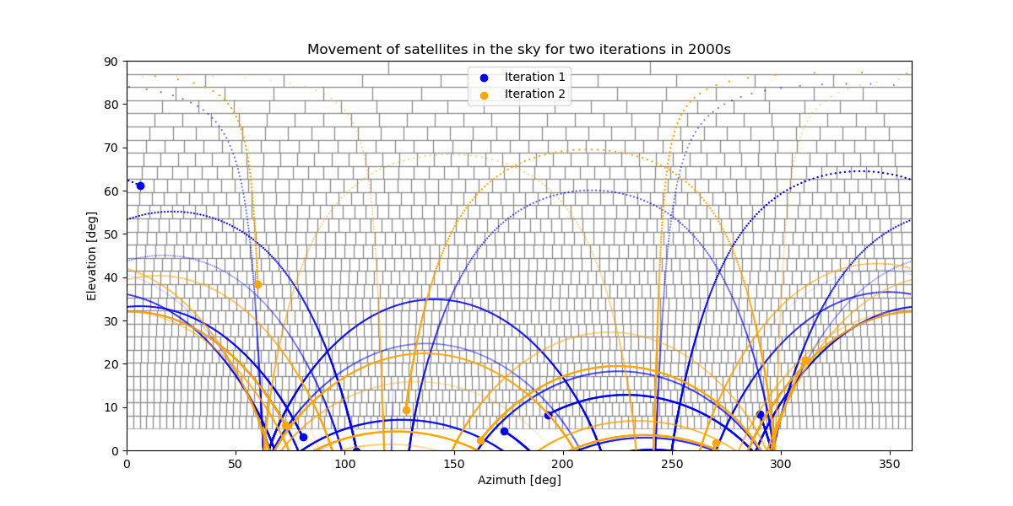
As described in the epfd method, the simulation must compute the satellite positions with much higher time resolution (usually 1 s) and then calculate the average pfd value over the full 2 000 s interval. Different states of the non-GSO satellite system should be captured, i.e., the whole simulation is repeated several times. The RAS antenna direction is considered by repeating the calculations for a grid of cells on the visible (topocentric) sky as shown in Figure 1.
Figure 2
Simulated epfd of the “System0" system in topocentric frame as received by a 25-m antenna
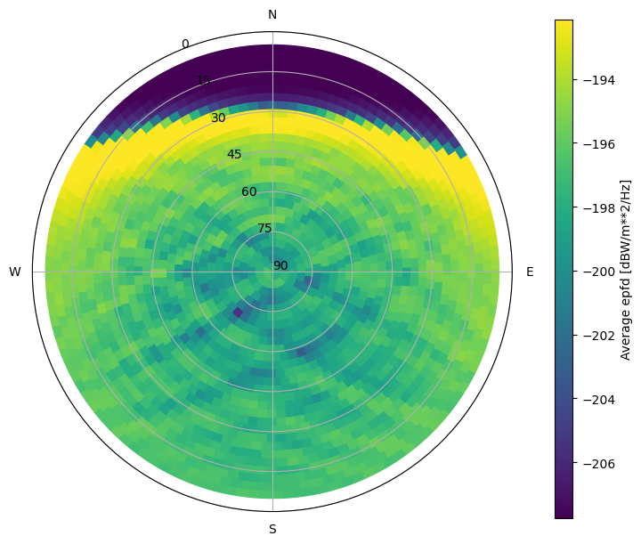
The result of all simulations is summarised in Table 3, where the maximum UEMR is shown as EIRP and equivalent electric field in dBμV/m measured at a 10 meter distance from a satellite. The values have been scaled from the 3.05 MHz of the RAS band to the 120 kHz of the typical detector resolution bandwidth used in typical EMC standards, considering the assumption that the UEMR is occupying the full RAS band. If an actual UEMR feature is known to have less bandwidth, a correction factor needs to be applied. Using electric field values is helpful as it can be compared to international commercial EMC standards such as CISPR-32.
Table 3
Results of maximum UEMR based on epfd simulations assuming
the UEMR is constant over the RAS band 150.05-153 MHz for representative satellite systems
non-GSO System | #Sats | Average Altitude [km] | Max EIRP  [dBmW/MHz] |  | Max E-Field [dBuV/m]  @10m distance  @120 kHz
 |  |  | Rx Antenna  D = 25 m | Rx antenna  D = 70 m | Rx Antenna  D = 25 m | Rx antenna  D = 70 m
System 0 | 100 | 400 | −53.5 | −56 | 22.06 | 19.56
System 1 | 100 | 500 | −52.8 | −55.3 | 22.76 | 20.26
System 2 | 100 | 700 | −51.9 | −54.2 | 23.66 | 21.36
System 3 | 100 | 900 | −51.1 | −54 | 24.46 | 21.56
System 4 | 500 | 400 | −59.9 | −61.9 | 15.66 | 13.66
System 5 | 500 | 500 | −59.4 | −61.4 | 16.16 | 14.16
System 6 | 500 | 700 | −58.6 | −60.6 | 16.96 | 14.96
System 7 | 500 | 900 | −57.8 | −59.9 | 17.76 | 15.66
System 8 | 1 000 | 400 | −62.8 | −64.4 | 12.76 | 11.16
System 9 | 1 000 | 500 | −62.3 | −63.9 | 13.26 | 11.66
System 10 | 1 000 | 700 | −61.5 | −63.1 | 14.06 | 12.46
System 11 | 1 000 | 900 | −60.8 | −62.4 | 14.76 | 13.16
System 12 | 4 800 | 400 | −69.6 | −71.1 | 5.96 | 4.46
System 13 | 4 800 | 500 | −69.1 | −70.7 | 6.46 | 4.86
System 14 | 4 800 | 700 | −68.3 | −69.9 | 7.26 | 5.66
System 15 | 4 800 | 900 | −67.6 | −69.2 | 7.96 | 6.36

Figure 4 compares the obtained levels of maximum UEMR from different representative constellations with the standard ECSS-E-ST-20-07C (ESA standard used widely for space missions as reference) and with the CISPR 32 class B standard (international standard for commercial residential IT equipment), it is easy to see a trend where the maximum UEMR diminishes as the number of satellites in the non-GSO system increases. For systems with as many as 4 800 satellites, the maximum UEMR level results in more than 20 dB below the CISPR standard.
Figure 4
Maximum UEMR levels for the systems in table 1. Blue bars represent RAS station with 25 m diameter,
Red bars represent RAS station with 70 m diameter
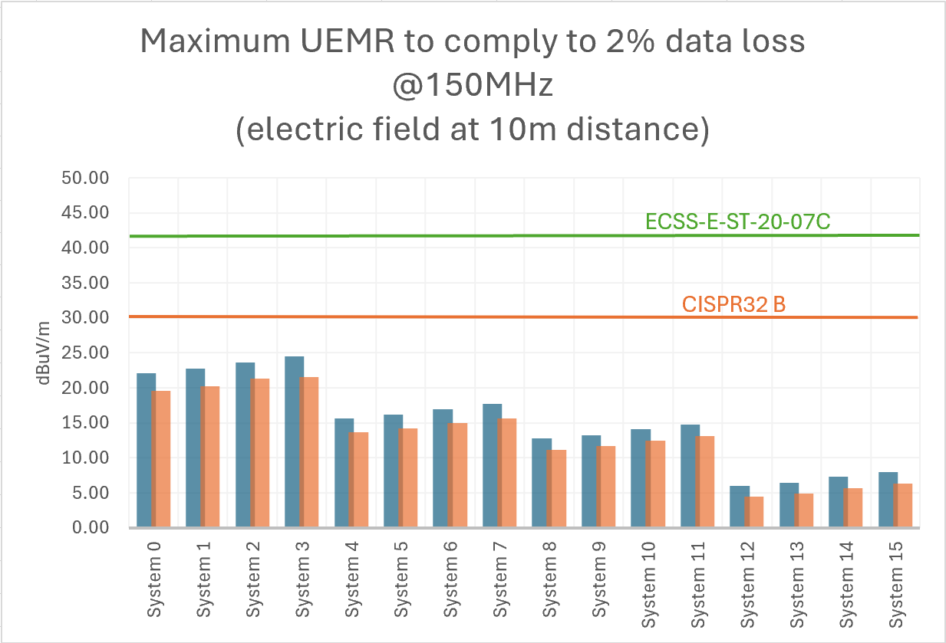

4.2 UEMR of satellite systems orbiting the Moon
Emissions in the Shielded Zone of the Moon (SZM) causing harmful interference to radio astronomy observation and other users of passive services are prohibited in the entire radio frequency spectrum with exceptions as per RR Nos. 22.22 to 22.25. The SZM offers a unique opportunity for radio astronomy to conduct observations in parts of the radio spectrum which on Earth are either too congested with man-made transmissions or are not possible due to the low transmission of the atmosphere. This is particularly true for frequencies in the 1 MHz to about 200 MHz range, where the emissions of the epoch of reionisation (EOR) are expected to be detected.
As well as intended transmissions, UEMR from satellite systems orbiting the Moon might cause harmful interference for radio astronomy, especially in bands where the EOR signal is expected. It is not possible to conduct a simulation of representative Lunar-orbiting systems, but the results from the previous section can be considered as also valid.
Satellite systems orbiting the Moon should regard the possible impact of their emissions on radio astronomy observations, initially by the simulation to consider the maximum UEMR and then by test on the ground previous to launch.

5 Examples of measurements of UEMR of satellite constellations
{Editor’s notes:
Neither the content nor location of this section has been agreed by WP 7D, further work is needed on this section.
An Administration expressed the view that this section should be deleted or moved into an annex with multiple examples.
This section could include different measurement campaigns, including EMC chamber measurements, radio telescopes and satellite monitoring stations if available.}
Ideally, UEMR should be measured in controlled environments such as an anechoic chamber, where not only the exact radiation levels can be measured but also the radiation pattern of a satellite can be obtained by performing measurements for many different directions. EMC testing of a fully integrated satellite is usually done with limited time and therefore performed as a “system check”, where the UEMR is measured in some directions towards the spacecraft while being operated in some operation modes, therefore the available information can sometimes not be enough to discuss the potential harmful interference into RAS bands.
Another option to conduct measurements of UEMR from satellites is to do it after deployment, using an antenna with high gain or a radio telescope. This section describes different results of measurement campaigns used to characterize unintended radiation from satellite systems.

5.1 Observation of UEMR with the LOFAR radio telescope
Using the LOFAR telescope a group of non-GSO satellites was observed in April 2021 for one hour in frequencies between 110 and 188 MHz. The LOFAR radio telescope is a network of radio telescopes spread across Europe with a dense core in the north of the Netherlands. Emissions from 48 satellites, out of 68 observed, were detected while the satellites transited the station beam of the LOFAR core. To enable positional discrimination, which is required to disentangle satellite radiation from terrestrial features, so-called tied array beams (TABs) were formed within the station beam by beamforming. The TABs are displayed in Fig 3. They span a hexagonal grid of “sky pixels” and for each of them, spectra were recorded, having integration times of 10.5 ms and spectral resolutions of 12.21 kHz.
The station beam pointed approximately towards zenith, an area in the sky that exhibited the maximum density of satellites because the geographic latitude of LOFAR is similar to the inclination of a satellite constellation’s orbit shell. Using publicly available ephemerides the position of each satellite was calculated and that was correlated with the signals detected in each TAB.
Figure 3
Arrangement of the TABs of the LOFAR telescope, solid lines are trajectories of satellites.
Orange are satellites at operational altitude, Blue are satellites in orbit raising. Image source:
Di Vruno et al. A&A 676, A75, p 20ff, 2023
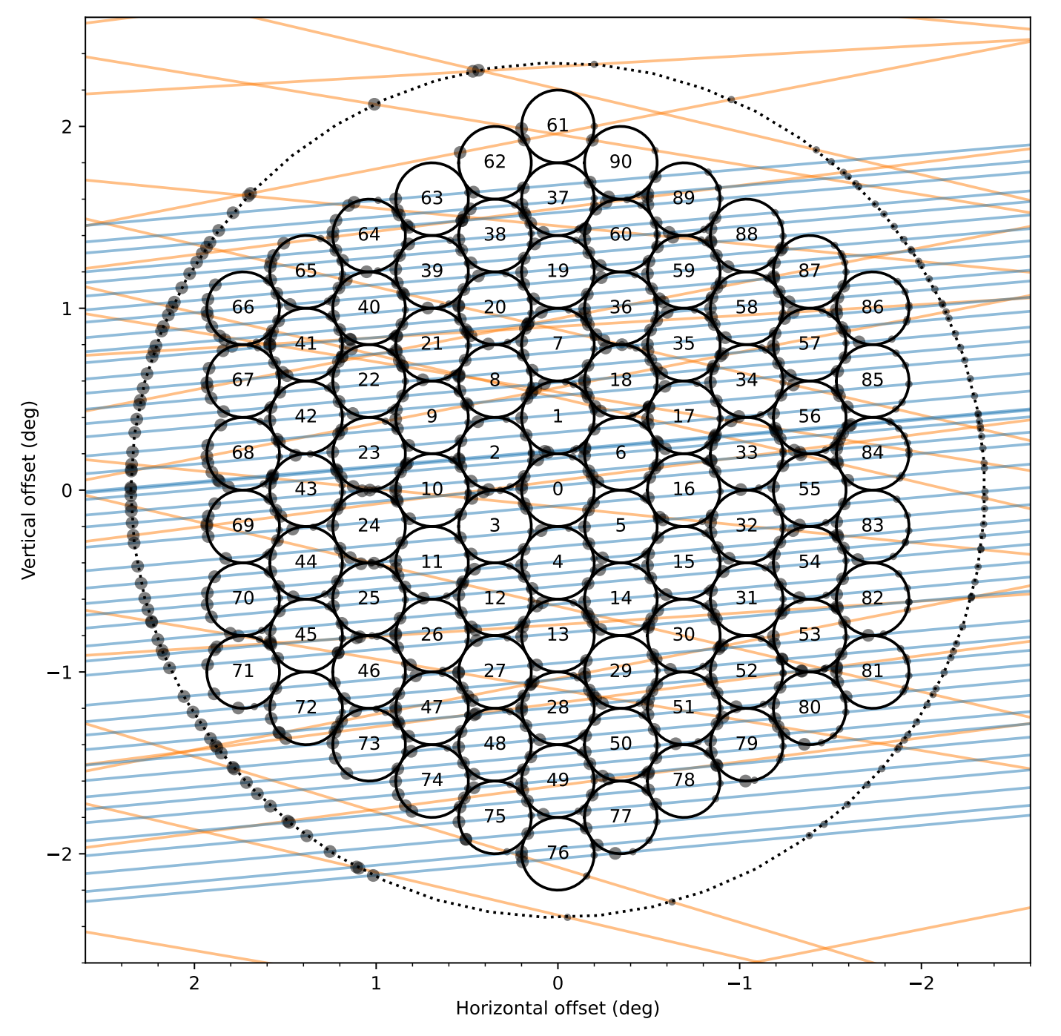
Different signals were detected in the observed LOFAR band, some broadband covering almost the entire frequency range and some narrowband. Considering the distance to each satellite and free-space path propagation loss, the received power was used to calculate the EIRP for each satellite. This EIRP was used later to calculate the electric field which would be measured at a distance of 10 metres, to be able to compare to simulations in Section 4 and to terrestrial and space EMC standards.
Figure 4
Example of broadband and narrowband radiation from one satellite (at time offset = 0 s the satellite transited the TABs). Image source: Di Vruno et al. A&A 676, A75, p 20ff, 2023
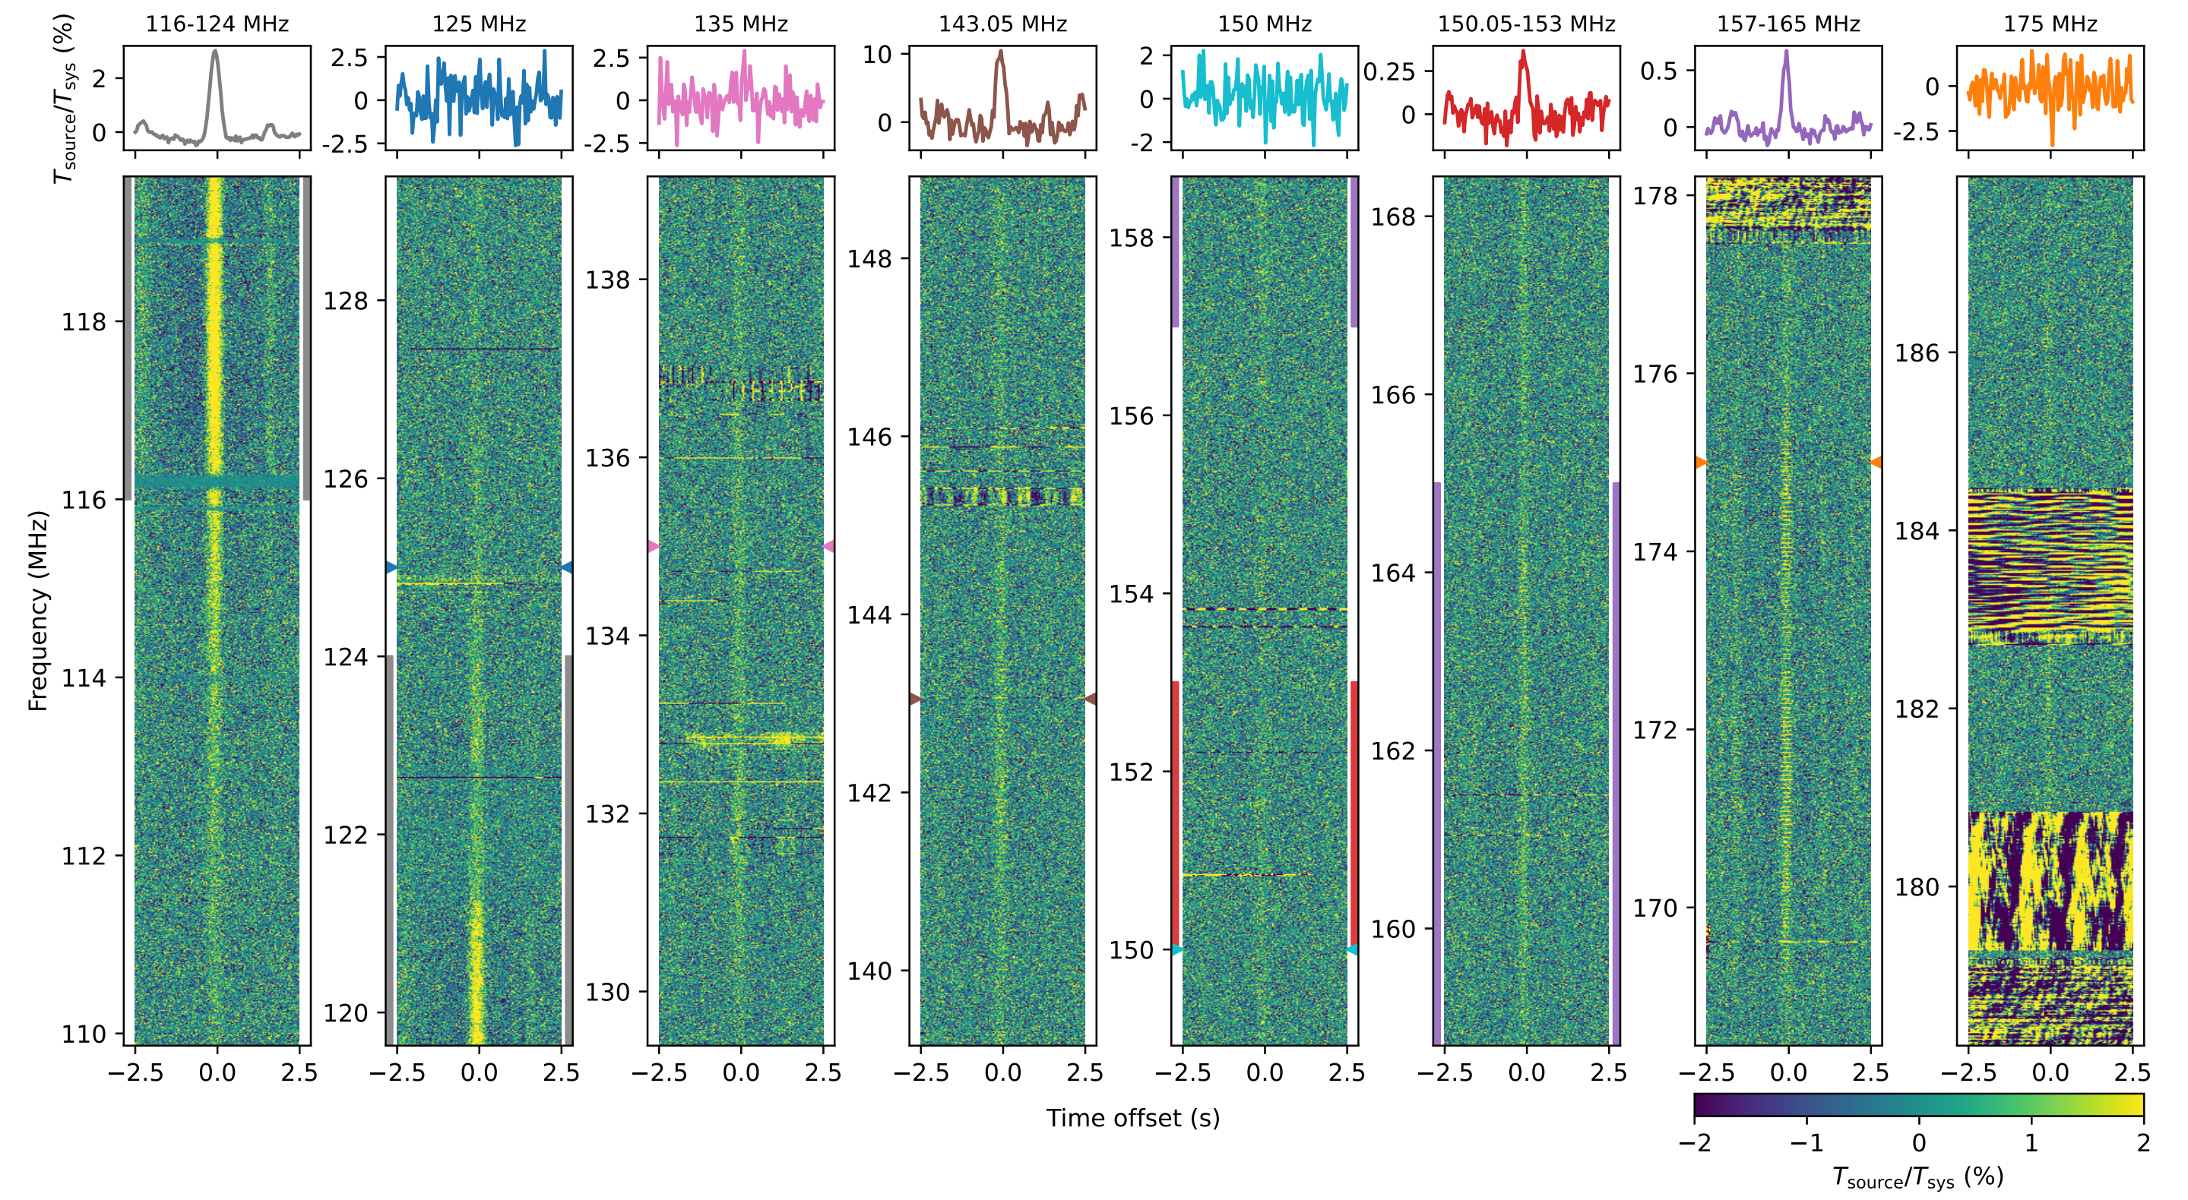
Figure 4 shows the spectral and temporal properties of one satellite transit (averaged over 10 TABs). Normalised, aligned and averaged dynamic spectra are shown over the entire observed bandwidth and within ±2.5 s of the predicted passage time, the radiation detected is centred at t = 0 when the satellite is transiting each TAB. Time series at narrow-band frequencies of 125, 135, 143.05, 150, and 175 MHz, as well as for broad-band frequency ranges (116 to 124, 150.05 to 153, and 157 to 165 MHz) are shown in the top panels. The colour of each time series matches the marked frequencies or frequency ranges in the same colours to the sides of the dynamic spectra. In this example, a combination of broad-band and narrow-band emission is visible including broadband emission inside the 150.05-153 RAS band.
The result of the measurement is summarized in Table 4, where the average EIRP and E field at a 10 m distance are included in different frequency bands. Note that in the RAS frequency band, the radiation measured is higher than the calculated maximum E-field in section 4.
Table 4
Summary of weakest and brightest UEMR detections from the observed non-GSO satellites
Table source: Di Vruno et al. A&A 676, A75, p 20ff, 2023
Frequency | Type | Altitude [km] | EIRP [dB(W/Hz)] |  | E-Field [dB(μV/m)]
 |  |  |  |  | BW= 120 kHz |  | BW = 2.95 MHz
 |  |  | min | max | min | max | min | Max
116-124 | Broad-band | ~360 | −141 | −130 | 24 | 35 | 38 | 49
 | Broad-band | ~550 | −139 | −133 | 26 | 32 | 40 | 46
125 | Narrow-band | ~360 | --- | --- | --- | --- | --- | ---
 | Narrow-band | ~550 | −124 | −113 | 32 | 43 | 32 | 43
135 | Narrow-band | ~360 | --- | --- | --- | --- | --- | ---
 | Narrow-band | ~550 | −128 | −123 | 30 | 35 | 30 | 35
150 | Narrow-band | ~360 | --- | --- | --- | --- | --- | ---
 | Narrow-band | ~550 | −128 | −123 | 28 | 33 | 28 | 33
150.05-153 | Broad-band | ~360 | −142 | −132 | 24 | 34 | 38 | 48
 | Broad-band | ~550 | −141 | −135 | 24 | 31 | 38 | 45
157-165 | Broad-band | ~360 | −140 | −127 | 25 | 39 | 39 | 52
 | Broad-band | ~550 | −145 | −138 | 21 | 27 | 35 | 41
175 | Narrow-band | ~360 | --- | --- | --- | --- | --- | ---
 | Narrow-band | ~550 | 126 | −107 | 30 | 49 | 30 | 49

5.2 Observations of UEMR with the Owens Valley Long Wavelength Array
The Owens Valley Radio Observatory Long Wavelength Array (OVRO-LWA), located in California USA, is a low frequency radio telescope covering 10 to 88 MHz. The telescope aims at studying the early universe, cosmic magnetic fields, solar activity, and exoplanets. The array consists of 352 dual-polarized wide-field dipole antennas, spread across an area of approximately 2.5 kilometers.

The OVRO-LWA software correlator continually produces visibility data over 10-second intervals, channelized over 195 kHz bands. Data calibration is performed using "A-team" sources such as Cassiopeia A and Cygnus A as references. The purpose of calibration is to correct the correlated data for instrumental and atmospheric effects. These sources are well-characterized in terms of flux density and position. The calibration process solves for phase and amplitude shifts to align observed intensities with true source flux densities, and compensates frequency-dependent system responses across the telescope bandwidth. Subsequent imaging process consists in shifting the observational phase center to the local zenith.

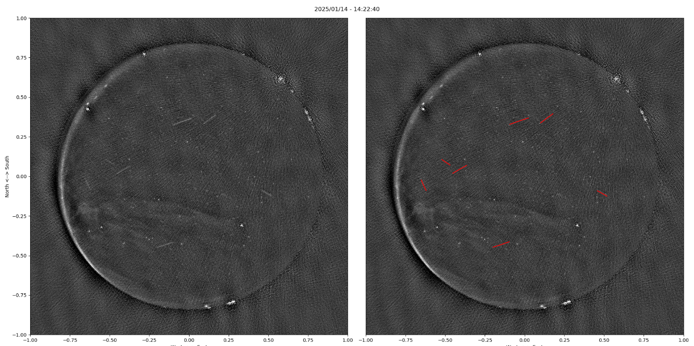
Figure 5 (Left) shows an example of all-sky image produced from a 10s data set captured in the 59-64 MHz band on 2025/01/14 at 0:03 am UTC. The edge of the circular image represents the horizon, and the center of the image represents the local zenith. Bright spots along the circular edge represents ground-based power-line interference.(Right) The same as on the left with red streaks marking positive matches with satellite ephemerides.

The radio images are analyzed to detect the presence of streaks resulting from unintended emissions from Low-Earth Orbit satellites within the field of view. Detected streaks are then compared to standard public satellites ephemerides databases. This cross-referencing helps confirm whether the detected signals correspond to known satellites or if they might represent unknown or transient phenomena. The three streaks on the left-hand side of Fig. 5 have returned positive matches with known satellites ephemerides, as shown on the right-hand side in Fig. 5 which overlaps the identified satellite ephemerides to the original all-sky image. No satellite systems have frequency allocations in the 59-64 MHz band, so the origin of these signals must certainly be unintended emissions.

{Further work will consist in quantifying the flux density of these satellite emissions, both in the 59-64 MHz band as well as in the 73-74.6 MHz RAS band. We will also produce statistics describing the occurrence of these events in the OVRO-LWA data collection.}

6 Summary
This report discusses the potential effects of UEMR from non-GSO satellite systems on RAS frequency bands. It is shown through simulations of several example systems that the number of satellites in a non-GSO system has a strong influence on the maximum level of UEMR that a single satellite can produce to still comply with the protection criteria for RAS as defined in Recommendation ITU-R RA.769 and data loss as defined in Recommendation ITU-R RA.1513.

7 References and related ITU-R Recommendations and Reports
Recommendation ITU-R RA.769 – Protection criteria used for radio astronomical measurements
Recommendation ITU-R S.1586 – Calculation of unwanted emission levels produced by a non-geostationary fixed-satellite service system at radio astronomy sites
Recommendation ITU-R M.1583 – Interference calculations between non-geostationary mobile-satellite service or radionavigation-satellite service systems and radio astronomy telescope sites
Recommendation ITU-R RA.1513 – Levels of data loss to radio astronomy observations and percentage-of-time criteria resulting from degradation by interference for frequency bands allocated to the radio astronomy service on a primary basis
Recommendation ITU-R RA.1631 – Reference radio astronomy antenna pattern to be used for compatibility analyses between non-GSO systems and radio astronomy service stations based on the epfd concept
Di Vruno, et al. – Astronomy & Astrophysics, Volume 676, id.A75, 20 pp., 2023, DOI: 10.1051/0004-6361/2023463744

8 List of acronyms and abbreviations
AAA AAA
BBB BBB

See Report ITU-R RA.2259 – Characteristics of radio quiet zones.
See ECC report 271 – Compatibility and sharing studies related to NGSO satellite systems operating in the FSS bands 10.7-12.75 GHz (space-to-Earth) and 14-14.5 GHz (Earth-to-space).

